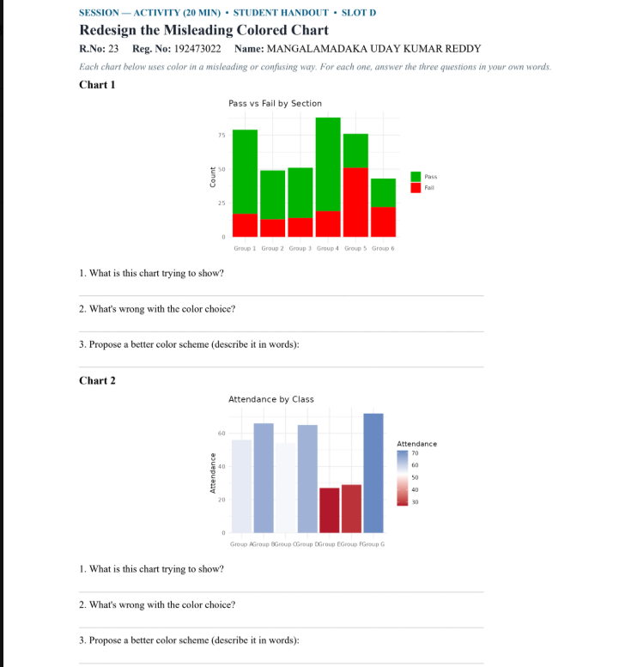
ANSWERS:
Chart 1 — Pass vs Fail by Section
1. What is this chart trying to show?
It shows the number of students who passed and failed in each group/section.
2. What's wrong with the colour choice?
The colours green and red can be confusing because red usually suggests something negative and green something positive, but the strong colours can also make the chart harder to read and compare.
3. Propose a better colour scheme:
Use one consistent, easy-to-read colour for Pass and another contrasting color for Fail, such as blue for Pass and light Gray for Fail.
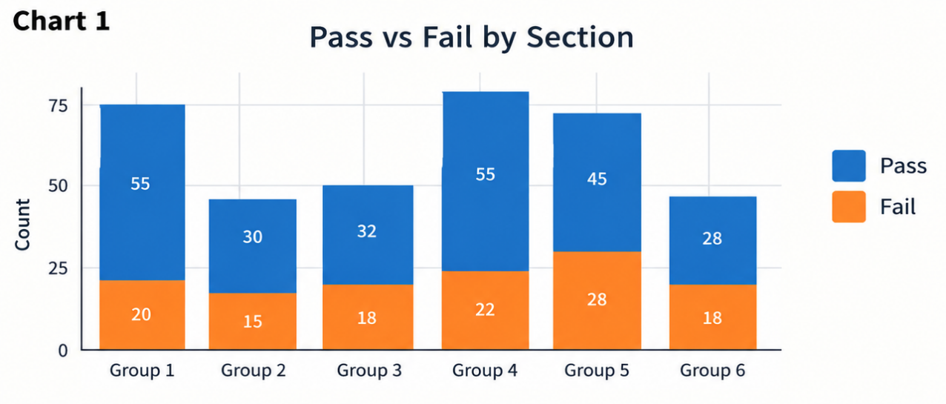

Chart 2 — Attendance by Class
1. What is this chart trying to show?
It shows the attendance level of students in different classes/groups.
2. What's wrong with the colour choice?
The chart uses different colours for the bars and a red-to-blue colour scale, which makes the chart confusing. The height of the bars already shows attendance, so the extra colour scale is unnecessary.
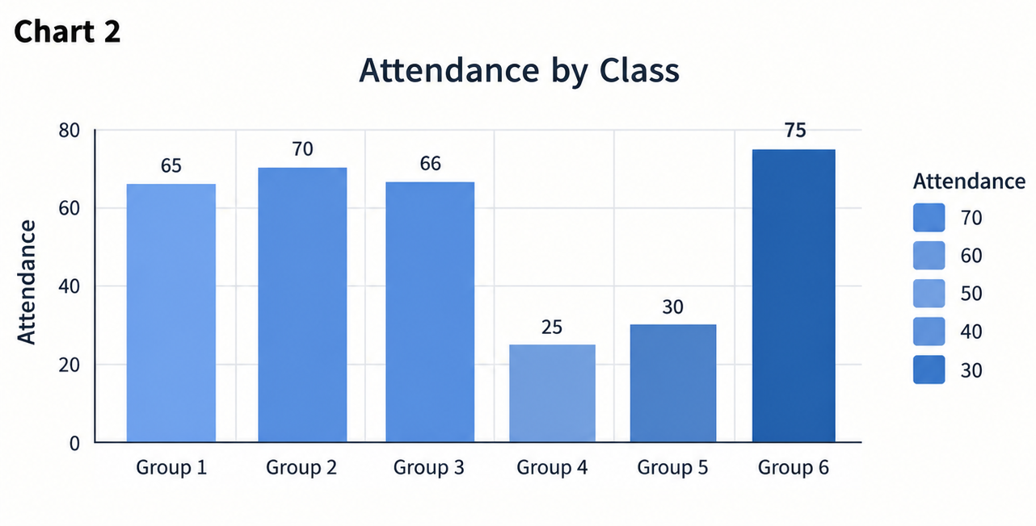
3. Propose a better colour scheme:
Use the same colour for all bars or use one simple colour gradient from light to dark to represent low to high attendance. Remove the unnecessary colour legend if bar height already shows the values.

